Asset Creation Report

For this assignment we were assigned to make some assets that would be used for a clone of Alien breed. For my Game I decided to go with a rocky Style of area so most of the assets that I created for my game are based of having a oldish look or being based with Rock textures in them.

The first thing I started by making was the character for my game I wanted to go with something quite simple but still wanted to go with a character that had a human body to it so ended up making a human body. but I gave it a texture that was very simple and with a glass panel as if the character was inside a suit.

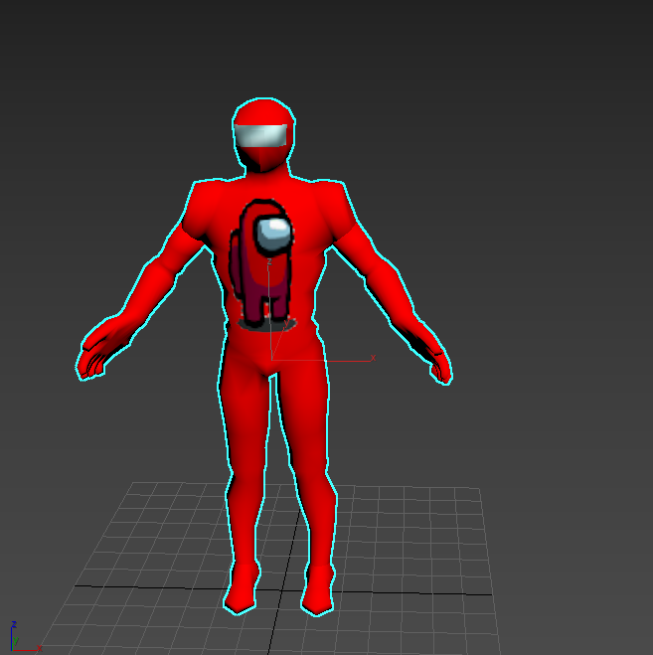

To make the body I had to use multiple tools and different objects which all started with standard cylinders or with a basic box that were shaped so that they would make it look like an arm or a leg or a torso of the human body. I used the Extrude function multiple times so that I would increase the size of the geometry so that it would fit the purpose of what I wanted to make. I used the connect tool so that I would be able to connect edges within a certain geometry so that I could then apply other modifiers to make it better or so that I way I could be able to move certain corners of the objects without having to move something I didn’t want. My body was also made by using a function called “symmetry”, which is very useful when u want to make objects that look the same when you cut them in half. After making the arms and the legs I had to use a tool called “target weld” which it makes a vertex connect to another this way two objects would be connected to each other without having to worry to use a Boolean. To add the arms and the legs I also had to use a function in the editable poly which is called “attach” that when you click on another object in the scene they will be attached together as if it was 1 single object. After finishing my Human body, I had to start thinking about making the texture which I had to use an Unwrap UVW so that I could then make a texture map for my character.  
However, since the UVW unwrap didn’t know how to cut my character apart I had to mark the points manually from edge to edge using the “point to point seam” tool to tell the UVW unwrap were I would like each part of my character to be cut by.  
After finishing the Texturing of my character I had to move on into working on the bones of my character which, I had to use the bone tool to make bones for each part of the body of my character which is the Spine, the legs, the arms and the neck and head. After making the bones I had to apply the skin modifier to my human body so that the bones and the body would count as one. In addition, I also had an structure of the bones that I had to organize so that it would look better, its not required but it looks better if I ever had the need to change something in it.

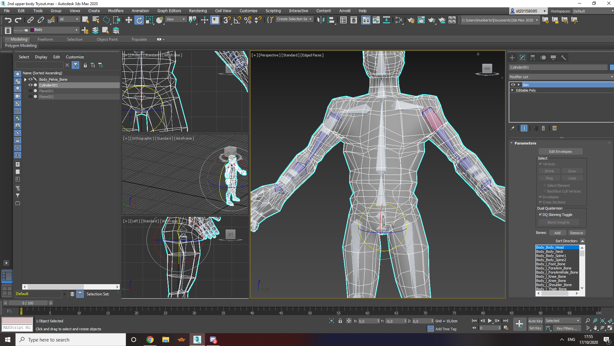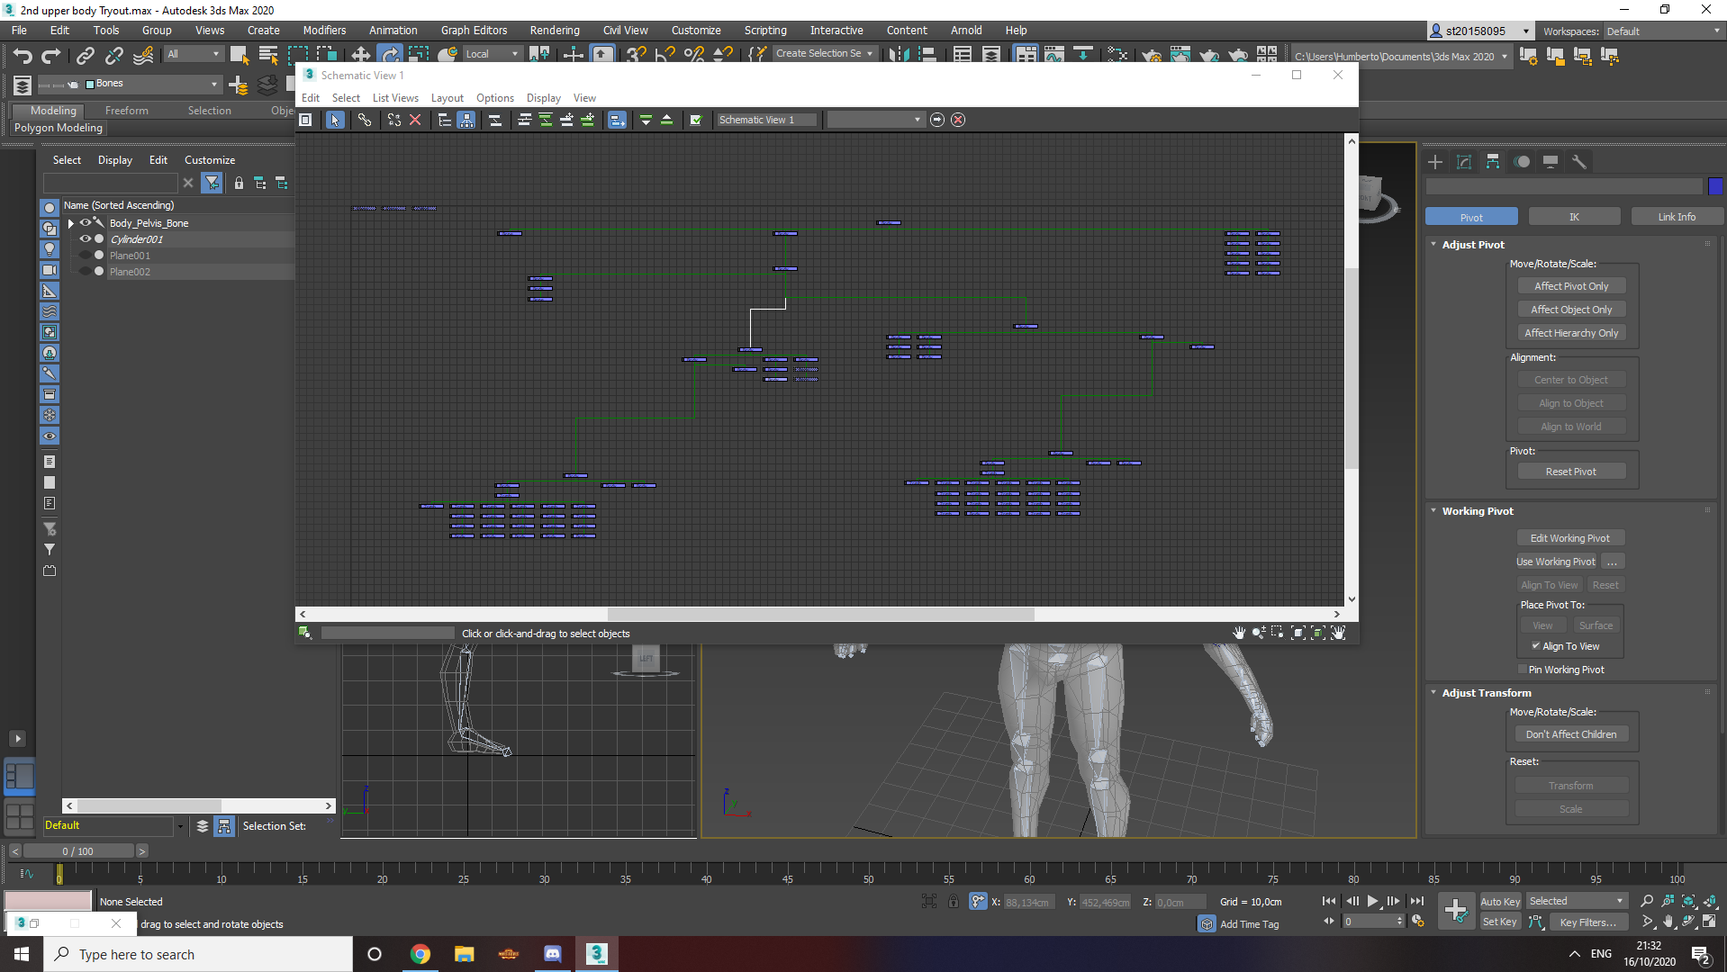

After applying the Skinning mod, I used Heatmap so that when I would try moving a bone in the human body it would deform in a way that looked more natural and it wouldn’t bend in weird ways. However, after this I still had to make sure that I would be able to control each part of the body without having to always look for the bones or turning of the geometry of my character, so I had to make controllers this way I would be able to make the character move just by using those controllers and nothings else. While making the controllers and bones I had to link all of them together by using the “linking tool”. I also had to use constraints tool so that it would make a bone not being able to move freely and only when I used a controller.   
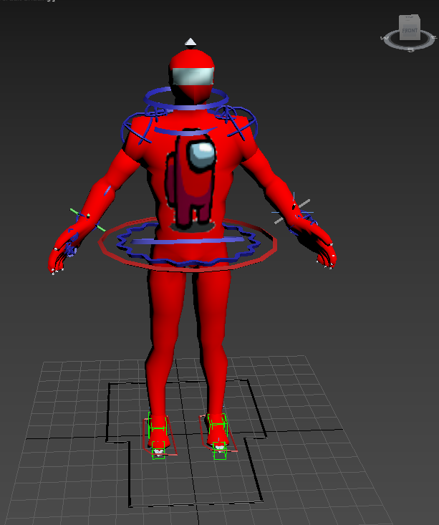  
Most of the controllers in my character also have applied attributes, which each one of them does a different thing for example the controllers in the fingers will control how much the finger will bend to the inside of the hands

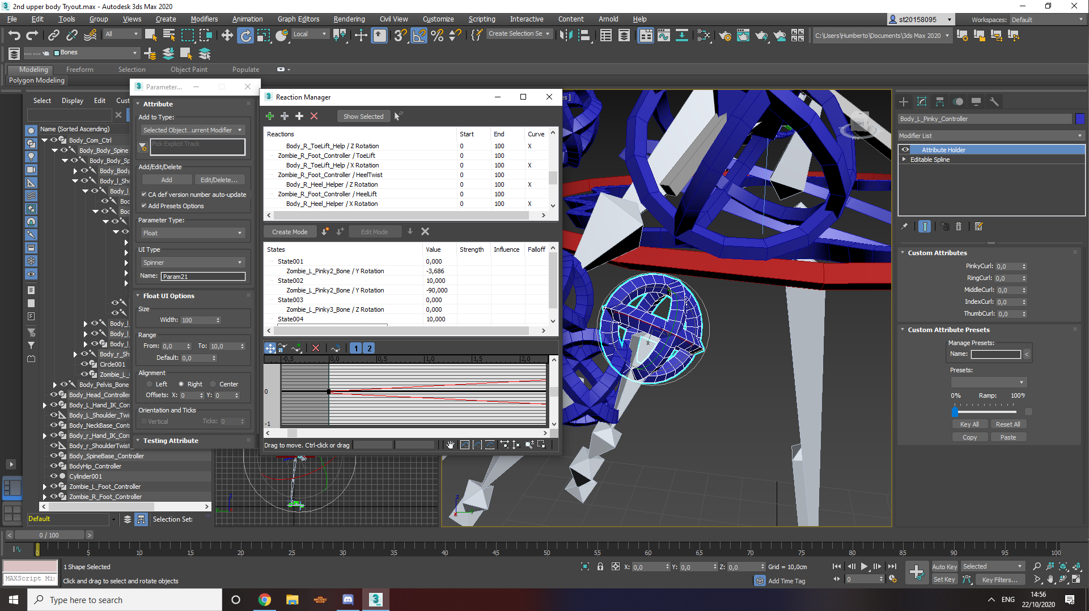  
After this long process My character was ready to be animated which will be shown in a video with the documents.   
In most of the objects of my game I used about the same tools and I used a lot of textures so that they look like a wall, rocks, floor, a target or a crate.   
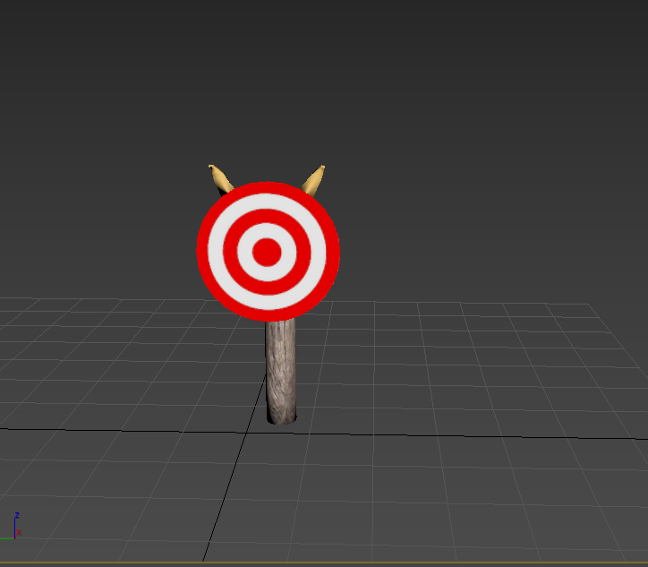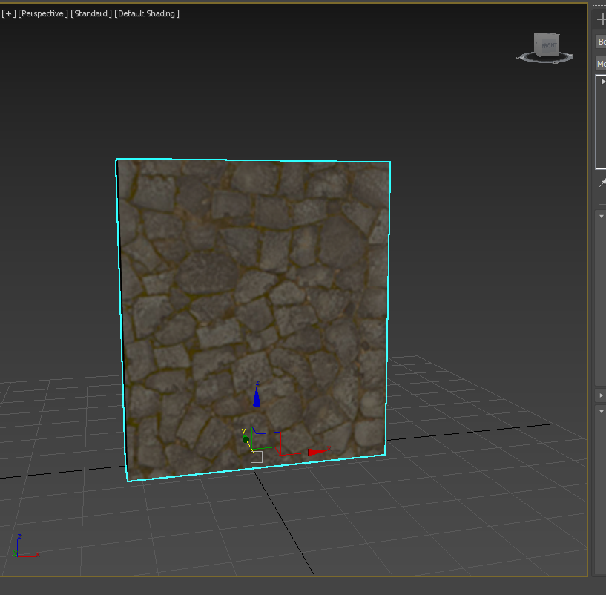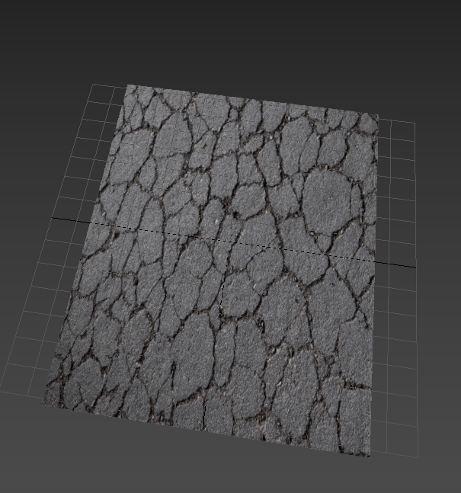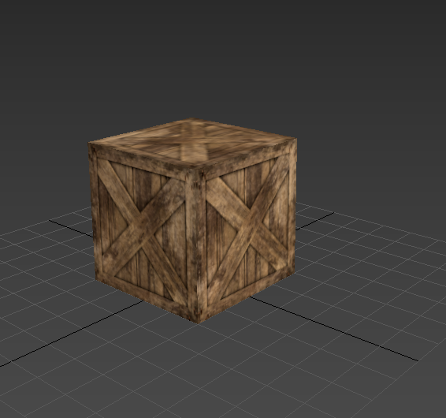  
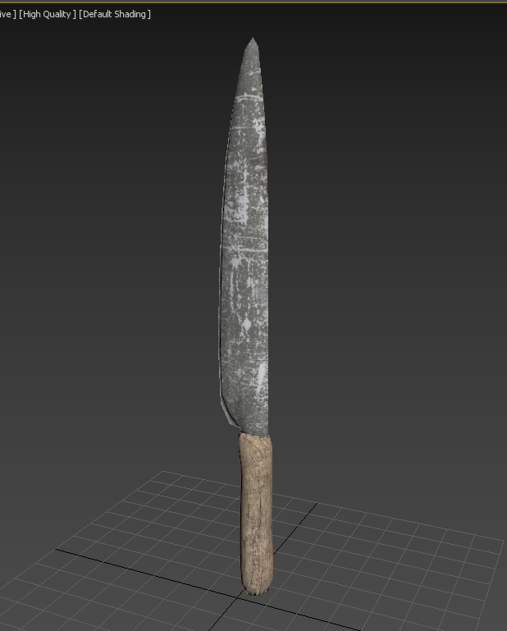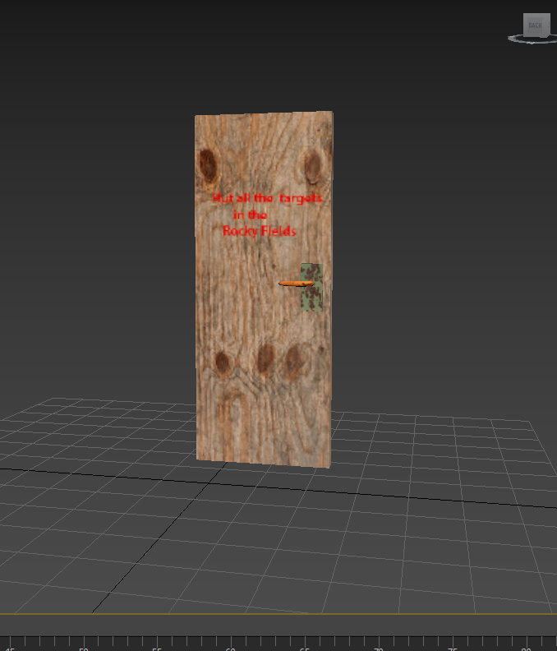

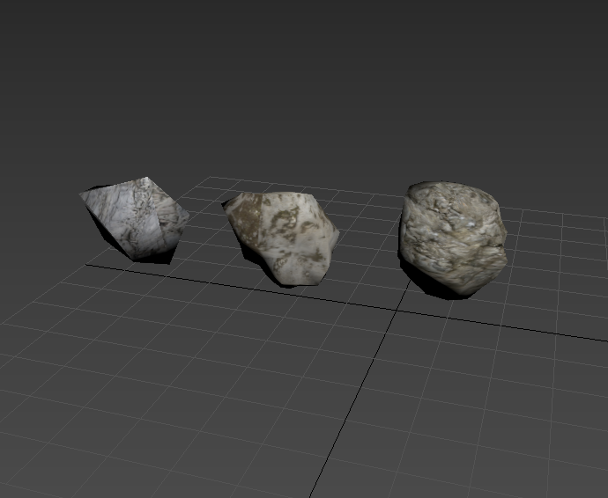  
With the rocks I had to make a sphere and use a displace tool which then has a cellular map on it to decrease the strength of the object which what it does it making the object go inside itself and creates bumps on the object and then I used to Cellular material so that when I increased the size of it it would revert the object and make side on the object and look like a rock which then I just had to apply a texture to them.

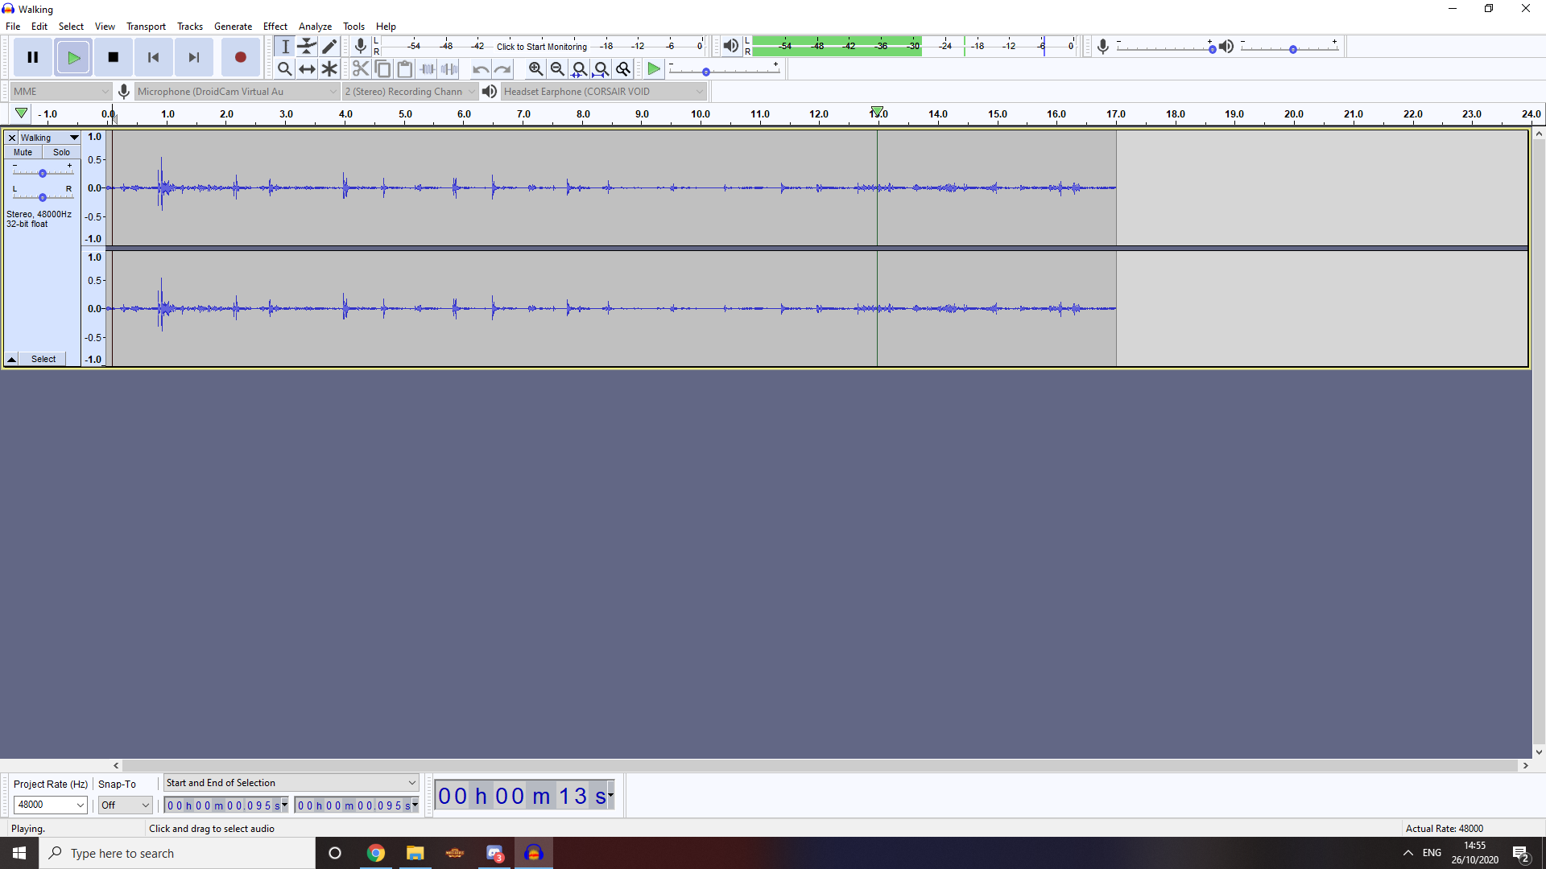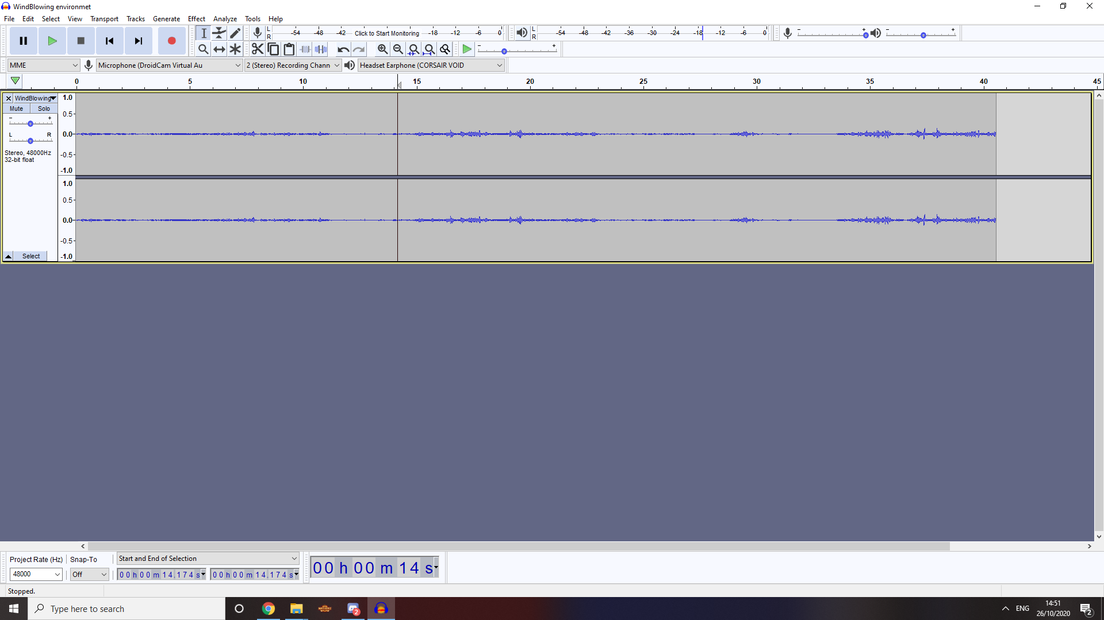  
All the sound effects that are used in my game are recorded by myself and then I just used audacity to remove parts of the sound that I wouldn’t use or that it would just sound to annoying. As an example, in the wind blowing I removed a lot of the wind blowing into the microphone of my phone. In the sound of a knife stabbing wood I decided to make two different sounds which one was strong and another one was weak but they were both recorded at the same time so I had to edit the sound so that I could have one that is strong and one that is weak

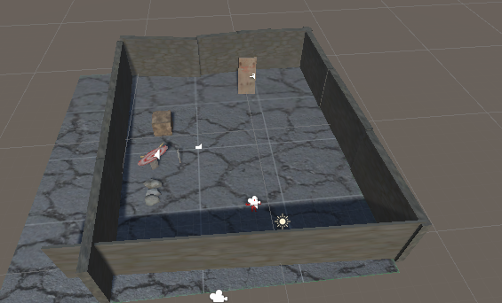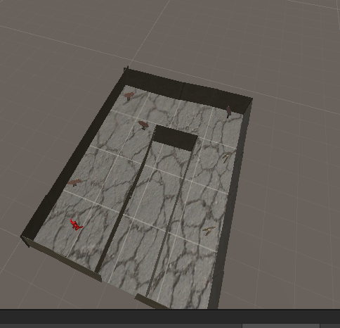  
For my levels I decided to go with something simple for my first level as I just wanted the player to first learn how to move and how to shoot and then on the second level, I decided to make the player have a bunch of more targets which they must hit in order to advance to the next level. The levels that I made were done by using the assets that I created before.